**Excel Assignment - 6**

**1. What are the various elements of the Excel interface? Describe how they're used.**

Ans-The Excel interface revolves around the ribbon, which is the strip of controls across the top section of the application window. The ribbon is comprised of tabs, which contain groups of controls, and this terminology is used to identify the location of tools. For example, bold font is applied to the selected range via the home tab, Font group, Bold button.

The following image shows the Excel 2016 application window with the home tab active and an open workbook containing one empty worksheet:

**Interface Components**

The interface components of Excel include the Quick Access Toolbar, Ribbon, Name Box, Formula Quick Menu, Formula Bar, Status Bar, Worksheet View Options, Zoom Slider Control, and the Zoom Percentage Indicator.

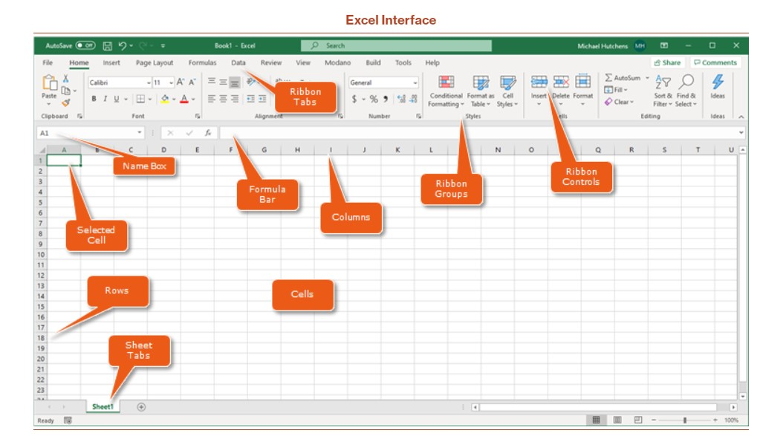

**Quick Access Toolbar-**

The Quick Access Toolbar is found on the top-left of the Excel window which contains the commonly used commands in Excel. This toolbar can be customized and lets you choose which commands you want to access easily. By default, this contains the save, undo, and redo commands.



**Ribbon-**

The Ribbon interface contains the commands that are available for use in Excel. This has multiple tabs including the File, Home, Insert, Page Layout, Formulas, Data, Review, View, Add-ins, and Help tabs. There are tabs that will appear when necessary; for example, the Format tab appears when you click an inserted shape.

**Name Box-**

The Name Box is an input box which normally displays the name or location of the active cell on the worksheet. This is also used to directly create a named range. When you open a blank workbook, the selected cell is A1, by default.

**Formula Quick Menu-**

The Formula Quick Menu beside the Name box is a shortcut when you want to insert a function. If you click the fx option, the Insert Function will pop-up to let you choose which Excel function would you like to use.

**Formula Bar-**

The Formula Bar is found just beside the Formula Quick Menu. This allows you to enter or edit data, formula or a function that will appear in the selected cell whose name or location appears in the Name Box.



**Status Bar-**

The Status Bar in the bottom-left corner of the Excel window displays various information about the current mode of the workbook.

**Worksheet View Options-**

The Worksheet View Options lets you choose which of the 3 worksheet views you want (Normal, Page Layout, or Page Break Preview). By default, the worksheet view is set to Normal.

**Zoom Slider Control-**

The Zoom Slider Control helps you zoom in and zoom out the worksheet.

**Zoom Percentage Indicator-**

The Zoom Percentage Indicator displays the zoom percentage just beside the Zoom Slider Control. By default, it is set to 100%.

**2. Write down the various applications of Excel in the industry.**

**Ans**-The most common business uses of MS Excel are business analysis, managing lists of people, operations management, and performance reporting. The software is also handy for office administration, project management, and managing programs, contracts and accounts.

**1. Business Analysis-**

The number 1 use of Microsoft Excel in the workplace is to improve business performance through analysis. This is essentially using collected data to inform decision making.

Businesses naturally gather data in their day-to-day activities, which may be data on product sales, website traffic, spending on supplies, insurance claims, etc. Analysis is the activity of converting data into something useful to the people who run the business.

For example, you could run a profitability report by day of the week. If the business always loses money on a Sunday, that information management could be used to decide to not open on Sundays.

Job examples: business analyst, business planning analyst, business solutions analyst, claims analyst, collections analyst, credit officer, data analyst, data and audience analyst, finance business analyst, investment operations portfolio analyst, junior data analyst, regional finance analyst, senior data analyst, senior finance analyst, senior portfolio analyst.

**2. People Management**

You may be surprised to learn that one of the top uses of Microsoft Excel in business is to manage people. An Excel spreadsheet is a powerful way to organise information about people, whether they are employees, customers, supporters, or training attendees.

Using Excel, information about an individual person can be stored and retrieved efficiently. A spreadsheet row or column can be used for an individual record that may include information like name, email address, start date, items purchased, subscription status, and last contact.

Job examples: client growth coordinator, client management and administration, client relationship manager, client service manager, client service specialist, employer service consultant, HR administrator, human resources administrative assistant, human resources administrator, human resources adviser, human resources officer, junior HR analyst, reconciliation and payments officer, relationship manager.

**3. Managing Operations**

Excel is relied on heavily to manage the day-to-day operations of many businesses.

While Amazon uses sophisticated custom software for operations management, Microsoft Excel is an important tool for many smaller businesses (or parts of larger businesses). An advantage of Excel is that it’s relatively low tech, allowing it to be used by many people and without the risk of programming bugs.

Business activities can often involve quite complicated logistics. Inventory flows need to be controlled so that you can keep operations running smoothly – and without overstocking on items. That means keeping track of supplier and client transactions, listing critical dates, and managing times and schedules.

Job examples: business operations analyst, data operations manager, graduate program – supply chain and operations, in market supply chain analyst, operational business analyst, operational enablement associate, operational knowledge management specialist, supply chain associate, supply chain specialist.

**4. Performance Reporting**

Performance monitoring and reporting is a specialised type of company analysis that can be done effectively using Microsoft Excel. For example, many accountants still use Excel (partly because it’s compatible with cloud-based accounting software).

A common way to convert data into a performance report in Excel is to create a pivot table. By inserting a pivot table and linking it to data, you can extra useful information from the dataset quickly. Pivot tables have numerous in-built functions that allow for tasks such as counting and summing certain types of data within the dataset.

Job examples: financial accountant, forecast analyst / sales support, performance analyst, performance analyst – procurement, professional services operations analyst, reporting analyst, reporting development analyst, sales coordinator, sales operations analyst.

**5. Office Administration**

Underlining the importance of Microsoft Excel, office administrators use Excel to enter and store key administrative data. The same data may be subsequently used for accounting and financial reporting, as well as operations analysis and performance reporting.

Apart from recordkeeping, Excel is useful in office administration for supporting day-to-day tasks such as invoicing, paying bills, and contacting suppliers and clients. It’s an all-purpose tool for keeping track of and managing office activities.

Job examples: administration assistant, administration officer, administration supervisor, administrative assistant, business operations and office manager, junior clerical and administrative officer, office admin manager, office support – maintenance / general duties.

**6. Strategic Analysis**

With respect to uses of Excel, strategic analysis is where business decisions are closely connected to the data and formulas on spreadsheets. You apply Excel to guide actions such as investments and asset allocations.

As an example, based on an Excel model, you may decide to take out currency insurance. Spreadsheet analysis is designed to inform business decisions in a specific way.

Job examples: asset manager – realty management division, mergers and acquisitions valuations – analyst, membership and campaigns strategist, portfolio administration associate, portfolio analyst, portfolio associate – wealth management, portfolio management officer – asset finance.

**10. Account Management**

Account managers are generally required to be competent Excel workbook users since they receive and need to maintain customer records. Excel is commonly used in account management since it provides a simple way to share and maintain client files.

The job of an account manager is to nurture relationships with existing clients of the business. Key goals are to achieve customer loyalty and repeat sales. It’s a marketing kind of role and a popular career for MBA graduates.

Job examples: account coordinator, advertising manager, design studio account manager, digital account manager, junior account manager

**3. On the ribbon, make a new tab. Add some different groups, insert commands in the groups and name them according to their commands added. Copy and paste the screenshot of the steps you followed.**

**Ans**-

Go to File > Options > Customize Ribbon.

Right-click on the ribbon and select Customize the Ribbon… from the context menu:

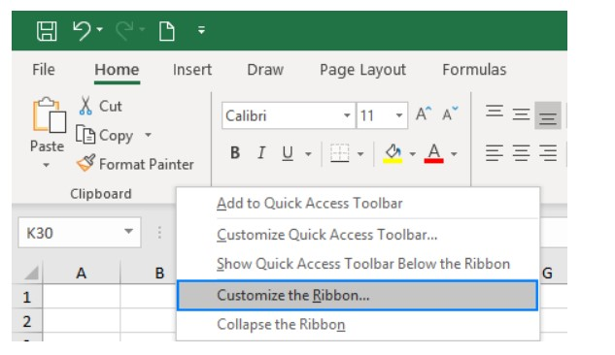

In the Customize the Ribbon window, under the list of tabs, click the New Tab button.

Select the newly created tab, named New Tab (Custom), and click the Rename… button to give your tab an appropriate name. In the same manner, change the default name given by Excel to a custom group. For the detailed guidelines, please see how to rename ribbon items.

On the right side of the Customize the Ribbon window, click on the item you want to rename.

Click the Rename button below the list if tabs.

In the Display name box, type the name you want, and click OK.

Click OK to close the Excel Options window and view your changes.

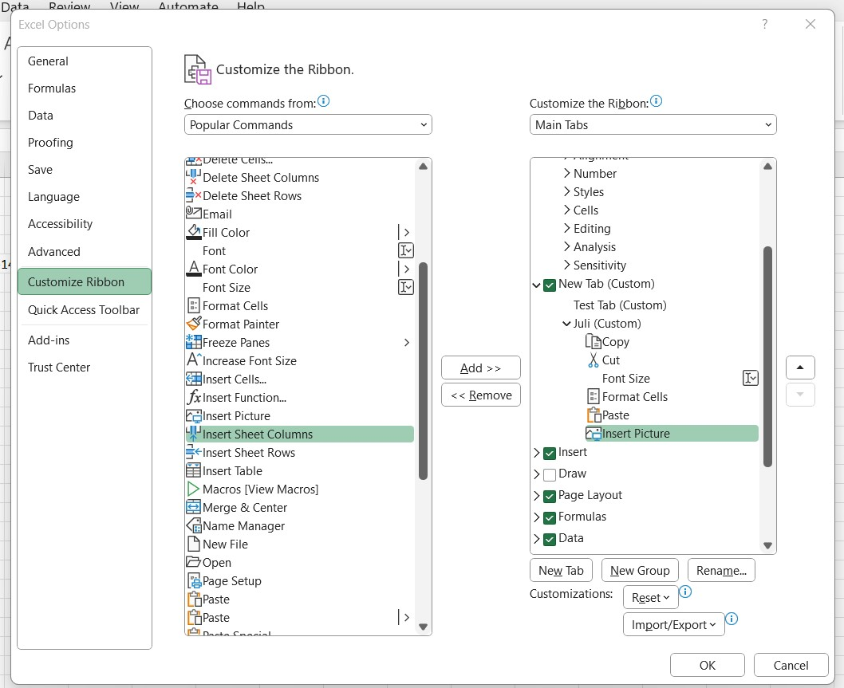

**4. Make a list of different shortcut keys that are only connected to formatting with their functions.**

**Ans**-

Copy: Ctrl + C

Cut: Ctrl + X

Paste: Ctrl + V

Maximize Window: F11 or Windows logo key window + Up arrow.

Open Task View: Windows logo key window + Tab

Display and hide the desktop: Windows logo key window+ D

Switch between open apps: Alt + Tab

Open the Quick Link menu: Windows logo key window + X

Lock your PC: Windows logo key window + L

CONTROL + B: Applies bold font formatting to headers.

ALT + H + B + A: Applies borders to the cells.

ALT + H + B + T: Gives an outline border to the dataset.

ALT + H + O + W: Autofits column widths

CONTROL + 1: Opens Format Cells dialog box.

**5. What distinguishes Excel from other analytical tools?**

**Ans**-

Microsoft Excel was released in the year 1985 and essentially is a tool that has features like calculation, graphing tools, pivot tables, and a macros programming language. It can be used on several operating systems such as Windows, Mac, Android, iOS, etc.

Next came Tableau. Founded in 2003, Tableau is an interactive data visualization software. It is recognized as the fastest growing data visualization tool mainly because of its ability to help users see and understand data. It simply converts raw data into a comprehensible visual that transforms the way people use data for problem solving and decision making.

Power BI was released in 2014. It is a cloud-based analytics and business intelligence service by Microsoft. It aims to provide interactive visualizations and business intelligence capabilities along with simple data sharing, evaluation of data and scalable dashboards to its users.

**1. Data Sources**

Excel, being a flexible, easy-to-use spreadsheet, is often used to create datasets. It can pull data from external data sources into your spreadsheet with the help of data connection features. It can also obtain data from sources such as the Web, Microsoft Query, SharePoint List, OData Feed, Hadoop Files (HDFS) etc. Consequently, Excel files are often used as a data source for Power BI and Tableau.

Tableau offers support for hundreds of data connectors including online analytical processing (OLAP) and big data options (such as NoSQL, Hadoop) as well as cloud options.

Power BI is very capable of connecting to a users’ external sources including SAP HANA, JSON, MySQL, and more. It enables users to connect to Microsoft Azure databases, third-party databases, files and online services like Salesforce and Google Analytics.

**2. Data Discovery**

Data discovery is a process for detecting patterns and oddity in your data by visually navigating data or applying guided advanced analytics.

While working with Excel, you’re required to have an idea of where the data needs to lead you in order to find critical insights. Options such as Stocks and Geography in Excel help with fetching specifics of the data quickly.

Tableau and Power BI allow you to freely explore data without knowing the answer you want ahead of time. Using this software, you can spot correlations and trends, and then dig down to understand what caused them to happen, rather than the other way around. These systems allow you to understand your data immediately.

**3. Data models and suitability**

Excel focuses on creating structured and simple data models with a wide range of features and is most suitable for statistical analysis of structured data.

Tableau allows you to create a simple data model, such as a single table or it can be more complex, with multiple tables that use different combinations of relationships, joins, and unions. It is most suitable for quick and easy representation of big data which helps in resolving the big data issues.

Power BI’s data models are focused on data ingestion and building potentially complex data models easily.

**5. Dashboards**

Excel provides limited features to create your dashboard and refreshing it is a tedious process. Tableau and Power BI allow you to create customized dashboards that consist of different types of charts, maps and diagrams. It is easy to refresh your dashboards using Tableau and Power BI and they give their users the ability to create aesthetically pleasing dashboards. When it comes to embedding data, this can easily be done on all three systems, however doing this is a real-time challenge in Tableau as compared to Power BI.

**6. User Interface**

To utilize excel to full potential, macro and visual basic scripting knowledge is required.

Tableau and Power BI boast interfaces that don’t require coding knowledge to develop sophisticated and complex visualizations.

Tableau has an intelligent User Interface and can create the dashboards easily. As compared to Power BI, Tableau is a little difficult.

The Power BI interface is very easy to learn. Because of its simplicity, Power BI is often preferred by users.

**8. Performance**

Excel runs on a moderate speed with no option to quicken. Tableau and Power BI also run on moderate speed with options to optimize and enhance the progress of an operation. Power BI is built for the common stakeholder, not necessarily a data analyst. In order to help teams build their visualization, Power BI’s interface depends more on drag and drop and intuitive features. Overall, when it comes to data visualization, Power BI wins for ease of use, but Tableau wins in speed and capabilities.

**9. Availability of data**

Excel is user specific. However, you can use Power BI to share your Excel workbook with your colleagues.

The visualizations created on Tableau can be stored and shared on the Tableau server with other Tableau users.

Power BI is focused on reporting and analytical modelling, and it allows you to store and share your dashboards by publishing it to a workspace so that everyone can collaborate on it. The storage capacity limits depend on the type of your workspace.

**6. Create a table and add a custom header and footer to your table.**

**Ans**-

1.Go to the Insert tab > Text group and click the Header & Footer button. This will switch the worksheet to Page Layout view.

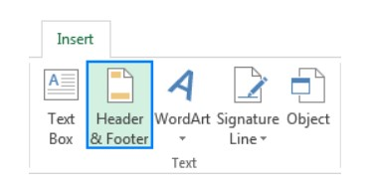

2.Now, you can type text, insert a picture, add a preset header or specific elements in any of the three Header boxes at the top of the page. By default, the central box is selected:

If you wish the header to appear in the top left or top right corner of the page, click the left or right box and enter some information there.

When finished, click anywhere in the worksheet to leave the header area. To exit the header box without keeping the changes, press Esc.

Like an Excel header, a footer can also be inserted in a few easy steps:

On the Insert tab, in the Text group and click the Header & Footer button.

On the Design tab, click Go to Footer or scroll down to the footer boxes at the bottom of the page.

Depending on the desired location, click the left, centre, or right footer box, and type some text or insert the element you want. To add a pre-set footer, please follow these steps, to make a custom Excel footer, see these guidelines.

When done, click anywhere in the worksheet to exit the footer area.

For example, to insert page numbers at the bottom of the worksheet, select one of the footer boxes and click Page Number on the Design tab, in the Header & Footer group.

Click the left, middle, or right cells at the top to edit the custom header.

Click the left, middle, or right cells at the bottom to edit the custom footer.

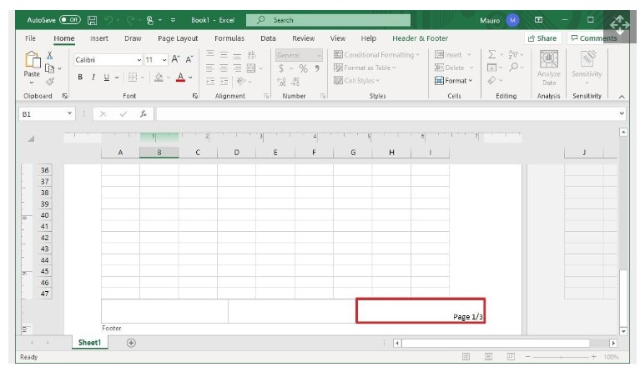

Use the "Header & Footer Elements" settings to insert predefined elements, including:

Page Number.

Number of Pages.

Current Date.

Current Time.

File Path.

File Name.

Sheet Name.

